Network Design Proposal (Parts 1-3)



Overview
-
You will provide a detailed network design proposal. Your task is to design the network for this new building with the following criteria:
- Each Classroom Computer Lab will be on a separate network (i.e., subnet). The Library Computer Lab will be on a separate network, and the Office / Admissions computers will also be on a separate network. Finally, the open-WiFi network should be on a separate network, but can use a private IP address range (i.e., 192.168.0.0).
- There must be a minimum of 40 Mbps Internet connection, with a backup line capable of at least 20 Mbps. Cable, DSL, or FIOS should not be used for primary Internet service.
- The network has been assigned the 199.1.2.0/24 network address for all computers and devices.
Your proposal will be submitted in three major parts:
- Physical Network Design
- Network Addressing
- Network Services Design
To learn how you will be assessed on this assignment, take a moment to review the rubric. The final deliverable should adhere to the following criteria:
- Include at least five scholarly references.
- Use IEEE-style citations.
- Use correct network terminology.
- The use of diagrams is encouraged.
Use this template as a guide while creating your Network Design Proposal (Parts 1-3).



Physical Network Design
-
In this section, address each of the following.
- Define the topology that will be used.
- Select the appropriate network media.
- Select the appropriate network connecting devices, including network security devices.
- Select the appropriate computer systems to use to support the network design.
- Determine a physical layout of the computers on the floor plan, along with the network wires (network wiring diagram).
- Provide justifications for each element of your network design (numbers 1–4 above).



Network Addressing
-
In this section, address each of the following.
- Watch How to Subnet a Network Video provided in Content -> Project Instructions
- Review the Network Address Template provided in Content -> Project Instructions -> Project Templates for Parts 1 - 3
- Complete the subnet chart provided at the end of the document.



Network Services Design
-
In this section, address each of the following.
- Identify network services needed.
- List additional servers or network devices needed to implement the network.
- List network security measures to be implemented.
- Justify the need for the network services, security measures, and devices you've selected.



Building Details
-
The 50-year-old, two-story building has the following layout:
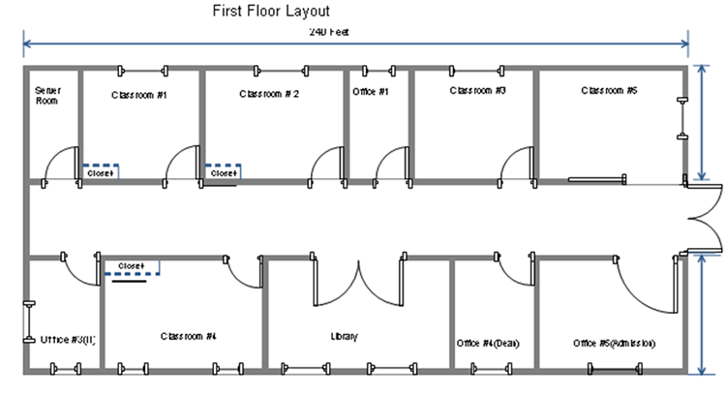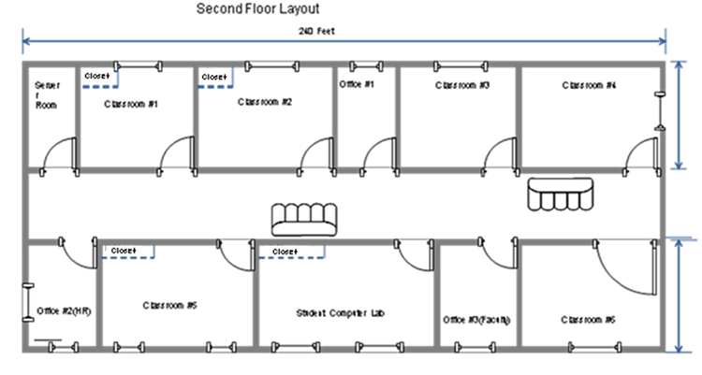
Building dimensions: length: 240 feet, width: 95 feet, height: 30 feet
The building will house six computer labs that will be used for instruction. In the building diagrams above, the labs are labeled Classroom #1, Classroom #2, and Classroom #4 on the first floor and Classroom #1, Classroom #2, and Classroom #5 on the second floor; each computer lab will have a closet. Each lab will have 25 computers: 23 student computers, one instructor computer, and one server in the closet for instructional use.
To allow students access to library resources, the library will also have 20 computers for the general public to use and five computers for library staff.
Finally, there are 7 offices in the building. Each of these offices will have one computer for staff use, with the exception of the admissions office, which will have five computers. There will be two server rooms, one on the first floor and one on the second floor.

